Callum McLaughlin

coursework two

Table of Contents

Digital Design and Production Report 3

Introduction 3

Map Design 3

Context of the Scene 3

Original Assets 4

Castle 4

Character Model 4

Punching Animation 5

Voice Lines 5

Conclusion 5

**Bibliography** 6

**Appendix** 7

Animation_Trigger Script 7

ActivatePlayerFPS Script 8

# Digital Design and Production Report

## Introduction

For this assignment instead of creating a game that showcased the requirements, a short cutscene was created instead inside a small level design. There were a number of different asset packages used such as Asphalt Materials (Manufactura K4, 2018), Grass and Flowers Pack 1 (Pochezhertsev, 2017), Rock and Boulders 2 , Standard Assets (Unity Technologies, 2020), Low Poly medieval buildings (Łukaszuk, 2017), Punching Sound Effect (Black, 2018), Medieval Village Environment (Asset Maiden, 2021).

The only script required for the project was an onTriggerCollision script which would activate the dialogue between the two characters in the scene as well as the animation and the camera switch to the cinematic camera.

## Map Design

The assets used included ones that were previously used in Coursework One such as the player model with the Punching animation, which was created in Blender, as well as the castle which was also created in Blender.

A medieval style was in mind when created the level design. A few houses and market stalls were created using the imported assets as well as a path throughout the small town leading to a mine at the edge of town. The town is also surrounded with large mountains which were created using the Rocks and Boulders 2 assets. The rocks were enlarged and when fitted together they looked like convincing mountains. The surrounding area is also cover with trees which were taken from the Unity Standard assets and grass which was possible by using the Grass and Flowers Pack.

The castle in the level is an original creation, made in Blender then imported into Unity where a low poly stone texture was then applied to it in engine.

## Context of the Scene

There is a single FPS controller which enables the user to navigate the map. This FPS controller was taken from the Unity Standard Assets Pack. The scene itself consists of another player model and a small medieval village, surrounded by forestry and mountains with a castle sitting atop a hill to the back right corner of the town. The “enemyPlayer” Model was created and imported from Blender, as well as the Punching Animation for that character model.

The scene is quite simple to navigate, the user simply walks from the start position and up the hill to the right into the castle grounds and upon approaching the figure inside the castle grounds they will trigger the “onTriggerEnter” method which will lock the players movement and switch to the cinematic camera. Then the “cutscene” will start playing with a few short voice lines from the character and one from the player, shortly after the punching animation plays. This short sequence is what was designed to display the design and importing techniques that was asked to be demonstrated in the coursework brief.

There was a small problem when testing the project where the FPS camera would be disabled, and the cinematic camera would be enabled as soon as the play button was clicked. To fix this, a new script was created and attached to the FPSController in the start method so that when the game started it set the FPSCamera enabled and the cinematic camera to disabled, this fixed the problem.

## Original Assets

Listed below are the original assets that were created as well as a screenshot of any physical assets for convenience.

### Castle

The surrounding walls and towers of this castle were created in Blender then imported into Unity where a stone texture was then applied.

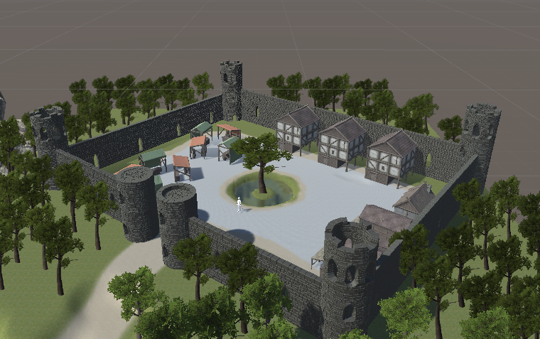

### Character Model

The character Model was also created in Blender and a punching animation was created with it which is also used in the scene.

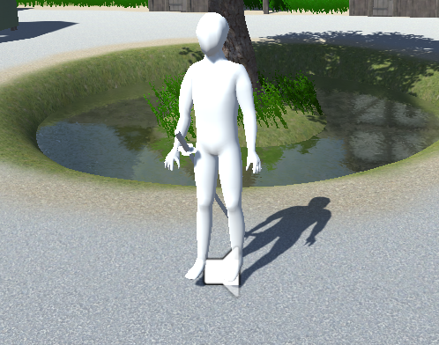

### Punching Animation

The punching animation that the enemyPlayer uses was created in Blender and imported into Unity.

### Voice Lines

The voice Lines for the scene were recorded in audacity and import as mp3 files into unity.

## Conclusion

Although the animation is short itself, adding some voice acting gave it a bit more appeal and realism. In order to do this some research into playing audio files in a dialogue between characters was required. Through this research, the following tutorial proved useful, “How to make a game for free – Voice Acting – Unity Tutorial” outlining how to do exactly what was envisioned, (Vegas, 2019). With all of this the desired scene was completed and all of the necessary steps to import assets from other applications were completed.

# **Bibliography**

Asset Maiden, 2021. *Unity Asset Store.* [Online]   
Available at: https://assetstore.unity.com/packages/3d/environments/fantasy/medieval-village-environment-121867  
[Accessed 16 04 2021].

Black, K., 2018. *YouTube.* [Online]   
Available at: https://www.youtube.com/watch?v=Ixnf7F3xw_A  
[Accessed 21 04 2021].

Łukaszuk, S., 2017. *Unity Assets Store.* [Online]   
Available at: https://assetstore.unity.com/packages/3d/environments/historic/lowpoly-medieval-buildings-58289  
[Accessed 02 04 2021].

Manufactura K4, 2018. *Unity Assets Store.* [Online]   
Available at: https://assetstore.unity.com/packages/3d/props/exterior/rock-and-boulders-2-6947  
[Accessed 13 04 2021].

Pochezhertsev, V., 2017. *Unity Assets Store.* [Online]   
Available at: https://assetstore.unity.com/packages/2d/textures-materials/nature/grass-and-flowers-pack-1-17100  
[Accessed 05 03 2021].

Unity Technologies, 2020. *Unity Assets Store.* [Online]   
Available at: https://assetstore.unity.com/packages/essentials/asset-packs/standard-assets-for-unity-2018-4-32351  
[Accessed 23 03 2021].

Vegas, J., 2019. *YouTube.* [Online]   
Available at: https://www.youtube.com/watch?v=dsFaVrgLKg0&t=637s  
[Accessed 16 04 2021].

## **Appendix**

### Animation_Trigger Script

using System.Collections;

using System.Collections.Generic;

using UnityEngine;

public class Animation_Trigger : MonoBehaviour

{

// NPC and Player gameObjects //

public GameObject theEnemy, thePlayer;

// Array for voiceLines/effects //

public AudioSource[] voiceLine;

// Cinematic camera //

public GameObject lockedCamera;

private void OnTriggerEnter(Collider collider)

{

// toggle the cinematic camera to active //

lockedCamera.SetActive(true);

// disable the players camera/movement //

thePlayer.SetActive(false);

// play first voiceLine

voiceLine[0].Play();

// play second voiceline after delay //

voiceLine[1].PlayDelayed(5);

// play third voiceline after delay //

voiceLine[2].PlayDelayed(10);

// Start Coroutine that plays animation //

StartCoroutine(playAnimation());

}

public IEnumerator playAnimation()

{

// adds delay before animation starts so voice lines can be played first //

yield return new WaitForSeconds(14);

// Plays punching animation //

theEnemy.GetComponent<Animation>().Play("Punching Animation (Cut)");

// Plays punching sound effect //

voiceLine[3].PlayDelayed(1);

}

}

### ActivatePlayerFPS Script

using System.Collections;

using System.Collections.Generic;

using UnityEngine;

public class ActivatePlayerFPS : MonoBehaviour

{

public GameObject thePlayer;

public GameObject lockedCamera;

// Start is called before the first frame update

void Start()

{

thePlayer.SetActive(true);

lockedCamera.SetActive(false);

}

}